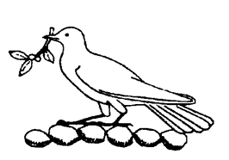
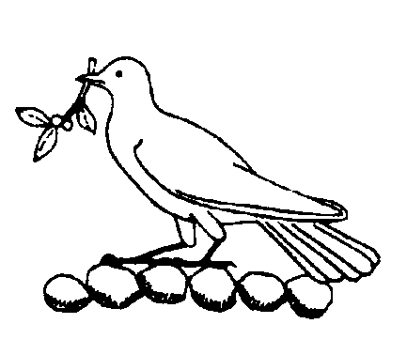
Croft parish council
Newsletter—Autumn/Winter 2016/2017
Christmas is fast approaching ….
Croft Parish Council wish everyone in the village a happy Christmas and a healthy and prosperous new year.
Dates for Your Diary:
 | Lights Switch-On  The Christmas tree has been ordered and the grand switch-on will be on Friday 9th December at 6.30 pm. Croft Silver Band will be playing.  We are not yet sure if Santa will be touring the streets of the village on Christmas Eve this year. Look out for posters and on the Parish Council website.  Church Services at St Michael and All Angels:  Saturday 17th December – 3.00 pm with Croft Silver Band. Mulled wine and Mince pies served afterwards......  24th December – Christingle Service - 3.00 pm  24th December – Midnight Mass 10.00 pm  Christmas Day – Family Eucharist with Carols, 10.00 am.


CROFT SILVER BAND
CHRISTMAS CONCERT
SUNDAY 4th DECEMBER
5.00 pm
Croft CofE Primary School
Tickets available on the door
£6.00 to include refreshments
Raffle
d refreshments
Enquiries 0145 282720
During December, the Church and School are taking part in a Posada which involves figures of Mary, Joseph and a wonky donkey moving from house to house looking for the stable. Each house is invited to take them in for one night before they move on. You may see them as you go round Croft. If so, please pay your respects. If you would like them to visit you, please contact Claire Jordan.
The 2017 Fun Day Next year’s Fun Day will be held on Saturday 10th June 2017 from 1.00 pm to 5.00 pm. Put this in your diary now!. If your group or charity wants a stall, bookings are now open - contact Steve Blackburn or Mike Ratcliffe – see page 3.

Croft Good Neighbours Scheme  The Croft Good Neighbours Scheme is sponsored by the Rural Community Council and Blaby District Council. The aim of the group is for volunteers, all from Croft, to offer help and assistance to people in Croft who are not always able to carry out some minor jobs for themselves. These might include small gardening jobs, minor repairs around the house (changing a light bulb for instance), dog walking, pre-arranged visits to a doctor or chemist or hospital (not emergencies). Some of our volunteers are confident working with computers, and some are prepared to help with completing more complicated forms. We may also offer to "chat" if that is what is needed. All volunteers have been checked by the Disclosure and Barring Service. Further details on 07590 246386. | A Conservation Area for Croft !  This is now in place ! The main purpose of conservation area designation is to acknowledge the special character of an area. This influences the way in which Blaby District Council, as the local planning authority, deals with planning applications that may affect the area. Within conservation areas, permitted development rights are restricted. This means that applications for planning permission are required for certain types of work that would not normally need consent. Although conservation areas mean some extra planning controls and considerations, these exist to protect the historic and architectural elements which make the place special. They are most likely to affect owners who want to work on the outside of their building or any trees on their property.

News from Croft CE Primary School
The school is going from strength to strength, we had some of the best SAT results in the county in 2016.
In September Ofsted visited and proclaimed our school to be 'Good'. Some of the comments were that leadership was 'dynamic and effective', pupils make ' good progress in learning with many pupils making outstanding progress', 'Pupils are well-behaved, polite and like their parents, proud of the school'. 'The governing body is fully committed to ensuring that pupils reach their full potential.'
We now offer 5 day a week pre-school, mums and tots group on a Friday morning and a brilliant breakfast club. We are over-subscribed in a couple of year groups but would welcome any families who would like to come for a tour and see how lovely our school is as we are planning on increasing our admission numbers due to demand.
Trudie Colotto, Headteacher

‘Ageing well’
The new Ageing Well Guide is now ready and available from Blaby District Council
The guide can be downloaded from the Blaby District Council website at www.blaby.gov.uk/ageing-well Hard copies of the guide are also available from Blaby District Council sites and have been circulated to libraries and GP surgeries in the district.

'Keeping Well This Winter'
Over a third of people in the UK aged over 65 say they
dread the cold weather in winter.

A joint initiative in it's 4th year, Blaby District Council, Blaby District
Staying Healthy Partnership and East Leicestershire CCG
have produced a booklet to help residents 'Keep Well This Winter'
The booklet includes information on:
* staying warm and safe
* flu information - including your FREE* vaccination
* NHS 111
* local NHS health services
* help with fuel costs
for more information or to request hard copies, please call 0116 272 7544

New Village Hall
Work is progressing slowly with a new architect commissioned to draw up plans for obtaining planning permission. We would very much welcome any volunteer with experience of fund raising bids especially if they involve large sums of money ! Other expertise is also welcome and if you think you would like to b e involved please contact, the Clerk, Steve Blackburn (address on page 3) if you can help.
 | 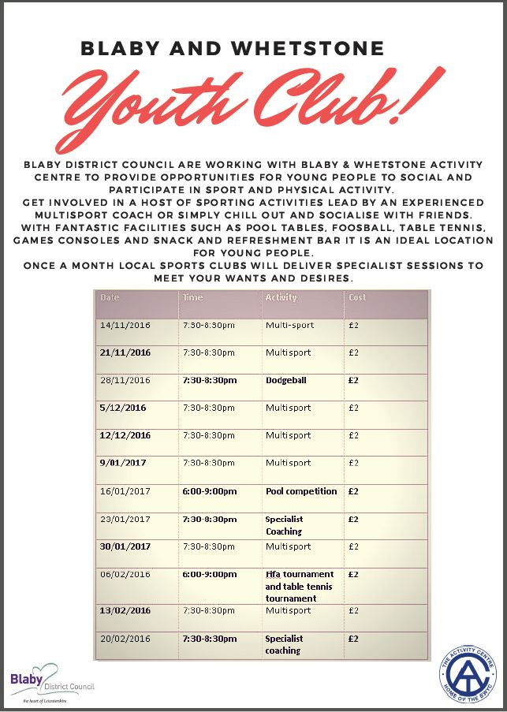
Your Councillors
Clive Mawby, Chairman  5 Salisbury Avenue | 285468 | Allotments  Have you ever fancied growing your own fruit and vegetables on your own allotment?  Our site at Arbor Road (near the County Council depot) has 112 plots and there are a couple of vacant plots available NOW and in plenty of time to be enjoying your own harvest next year. The annual rent is only £10. Contact Steve Blackburn, Clerk to the Council, for further details or just visit the sit and speak to other gardeners.
Philip Smith, Vice-Chairman  25 Sparkenhoe | 282470
Andrew Davies
7 Broughton Road
Chris Holmes  2 Brookes Avenue | 282703
Richard Howard  49 Broughton Road | 282284
Carl King
18 Bala Road
Mike Ratcliffe  6 Shades Close | 283382
Aaron Spence  Fulmore Farm, Croft Road, Cosby | 07767 787223
Clerk to the Council: Steve Blackburn  11 Wakes Close, Dunton Bassett, Lutterworth, LE17 5LL clerk@croftparishcouncil.org.uk  Council Website: http://croft.leicestershireparishcouncils.org/ | 209398
